1) Using the following, Table 3.1, provide the small peptides that will result using the specified cleavage method on the corresponding large peptide.

- Edman Degradation – QAYICKARLMMFETQWPIH

Fragments: Q, AYICKARLMMFETQWPIH

- Carboxypeptidase A – PYTVEKARLMFQQYCGYPA

Fragments: PYTVEKARLMFQQYCGYPA, YPA

- Carboxypeptidase B – KQEDFLMRGKLIYKWRIMS

Fragments: KQEDFLMRGKLIYKWRIM, S

- Hydrazinolysis – PYTVEKARLMFQQYCGYPA

Fragments: PYTVEKARLMFQQYCGYP, A

- Cyanogen Bromide – KQEDFLMRGKLIYKWRIMR

Fragments: KQEDFLM, RGKLIYKWRIM, R

- Trypsin – HQDAYYARLMRPNDPKCYP

Fragments: HQDAYYAR, LMRPNDPK, CYP

- Chymotrypsin – CHKFGSMVYFQADELWPHQ

Fragments: CHKF, GSMVY, F, QADEL, WPHQ

- Thermolysin – ERDNMVPLCYFHPIVDESQ

Fragments: ERDNM, VP, LC, Y, FHP, I, VDESQ

2) Draw the mechanism for the Edman Degradation. Cite the source you used.

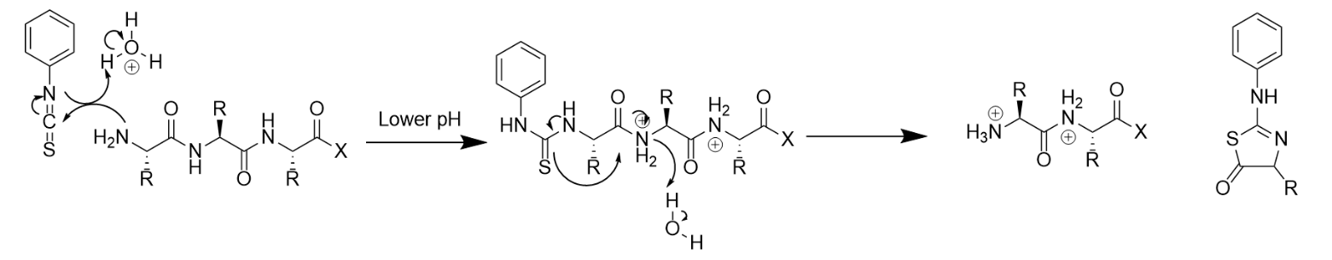

Sources:

The Edman Degradation https://chem.libretexts.org/@go/page/36472
Lehninger Principles of Biochemistry 7th Ed. by Nelson and Cox

